|  |  |
| --- | --- |
| Beautiful tree, vegetables, creative picture 1080x1920 iPhone 8/7/6/6S Plus  wallpaper, background, picture, image  Food classification vegetables | Project topic 4  Food classification  Group 2  Karin Pettersen, Tormod Müller, Aleksander Aaboen, Sander Island & Martin Iversen |

Table of content

Abstract 2

Introduction 3

State of the art 4

Method 5

Implementation 7

Results and discussion 8

Conclusion 9

Bibliografi 10

**TODO:**

* Finish abstract
* Write state of the art
* Finish Method
* Finish implementation
* Finish code and update/finish results
* Discuss the results
* Write a proper conclusion reflecting the results
* Update sources

# Abstract

This project is a part of the Computer Vision course, and the purpose of the project is to receive a different type of learning experience compared to just regular class work. In the project part of the course, we will learn to work in group with other students and receive knowledge on various areas of learning. That we will apply creatively to real-life situations, where the purpose of the project work in this class is to be able to classify a specific part of an image.

For this project, we have chosen to analyze an image of a dinner plate with the help of Matlab threshold color app and find out if the plate has vegetables. We have chosen to categorize the vegetables in different colors, that we believe are typical accurate for vegetables, and thus classify if the dinner plate contains vegetables.

The tool we have used in the project is the Matlab threshold color image. The app lets you segment color images by thresholding the color channels based on different color spaces. So, by using this app in our project, we can create binary segmentation mask for a color image.

# Introduction

The topic of the project is classification of food groups from food photography stock photos. We have chosen to focus on the colors that we believe are most relevant for categorizing vegetables. Thus, we want to be able to implement methods that will classify green, red, purple, yellow and orange vegetables in a photography of a dinner dish. To solve this topic, we will be using MATLAB.

We chose this task because we thought it seemed most interesting and exciting, and we thought it would be fascinating to be able to classify different vegetables on our dinner plate.

# State of the art

* Image segmentation today?
* Recent technological breakthroughs?
* Methodology we don’t have the exp to implement(machine learning etc)?
* Inspiration
  + <https://neptune.ai/blog/image-segmentation-in-2020>
  + Types of segmentation: <https://www.analyticsvidhya.com/blog/2019/04/introduction-image-segmentation-techniques-python/>
  + CGI technology: <https://medium.com/analytics-vidhya/computer-vision-segmentation-42ffff0d7d40>

Write a proper segment about the above

Image segmentation is an often-used technology in digital image processing, and it is the process of partitioning a digital image into multiple parts, called object parts. This makes the complicity of the image reduced and analyzing the image becomes easier.

Image segmentation is important because over the years segmentation algorithms and technics have been developed to solve segmentation problems in specific areas, which includes medical imaging, automated driving, video surveillance and machine vision. For example, is segmentation used in autonomous vehicles to help the system identify and locate vehicles and other objects on the road.

Image segmentation of food is widely used in food industry. Some of the areas in food industry it is used in are analyzing images of food to extract the nutrition content in the food. By combing image segmentation and classification you can estimate the type and weight of food, and thus estimate the nutrition on your dinner plate. Another example of use of food segmentation in food industry is using the segmentation and classification techniques for the verification of the quality of the cooking process of the food.

For our project we choose to use food classification, but a different method we could have used was machine learning.

# Method

We started browsing the web to learn about the different project topics we could choose from. Eventually we chose the Food-Classification topic. From there we started exploring the different methods to classify specific parts and colors within images.

Image segmentation is one of the well-known techniques in digital image processing to divide an image into multiple regions. The goal with image segmentation is to simplify an image, to a more meaningful or easier to analyze image. The main approach of this technique is to locate an object or boundaries, by assigning a label to every pixel in an image. As a result, every pixel assigned to the same label will share some characteristics. These characteristics can be color, intensity or texture.

In this project we are using Color Thresholding to classify different sections of a meal. The Color Threshold method is an algorithm used to select specific pixels from an image, that falls within a specified color range. The pixels which doesn’t satisfy the specified color section will become black, and the rest will become white. Therefore, we figured that this method was the best for our use-case after the use of Machine Learning. By using Color Threshold, we are in most cases able to easily distinguish between for instance meat and vegetables, or also the different types of vegetables, if desired. This is due to the vegetables often being different colors.

Using the Color Thresholder app from the Image Processing toolbox we were able to get an understanding about how we could select different pixel values from an image, and only select a section of these pixels from a specified color spectrum (in our case we used RGB). The app gave us a nice preview allowing us to get a great understanding about how it worked and which color values we had selected, which resulted in us selecting the methods used by the Color Thresholder app from the Image Processing toolbox as our base.

We exported the functions from the Image Thresholder app allowing us to use them in a more general way, and to choose the same pixel values from multiple images instead of doing it manually for each image. When using the functions we created with the Image Thresholder app we were able to modify the code where needed, but the exported functions converted our image into a binary image (from RGB), instead of giving us the RGB values of the pixels like the Image Thresholder app did. This resulted in the image being masked, this way, we are able to classify specific parts of the image easily.

The process continued by finding different images with different difficulty level. The images are classified as easy, medium, hard and problematic. All the images was run through the functions we made and from there we performed post image processing in the form of morphological opening.

By performing morphological opening, we remove small objects from an image while preserving the shape and size of larger objects in the image ([Morphological Operations](https://www.mathworks.com/help/images/morphological-dilation-and-erosion.html)). In our case, this means that we make a clearer object of the different vegetables and ideally are able to fight against reflection etc. a little bit better. For instance is the water and seeds inside a tomato, still a part of the tomato, even though it is not red like the outside of the tomato.

Explain what a binary mask is and why this tool fit our project case etc

# Implementation

Explain our work process, how we solved the task etc maybe move some filler from implementation to method What are the diff between method and implementation.

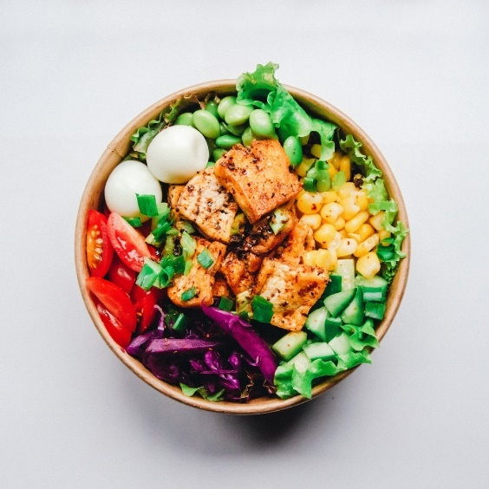We started development by looking for ways to segment an image into different areas of interest (finding borders etc). We investigated methods like k means clustering and other clustering algorithms. However, we quickly realized that using a basic image segmentation algorithm would not work for our case (classifying a type of food on a plate); when looking for pictures of different dishes containing vegetables in addition to other types of food, we realized that the food in a lot of cases is mixed unevenly on the plate (see figure 1). Using a basic clustering image to classify different sections of a plate or bowl like figure 1 the algorithms we tested did not give us any usable clusters.

Figure 1 A mix of different vegetables with no clear borders

Write more about the machine learning and border detection algorithms we looked at here

Looking in the inspiration document provided by our teaching assistant we decided to go with the colour thresholder app in the *Matlab image processing toolbox*, a tool which lets a user create a function which creates a binary mask containing specified parts of a colour space. We decided to use this tool to classify specific colours, these colours being the most common colours found in vegetables and then layering the masks on top of each other to create an image containing only the classified areas in the image.

Write more about testing, meetings and report writing

# Results and discussion

During early testing we encountered our biggest hurdle in this project: Light and reflection: When classifying different food on a plate the biggest issue is classifying the parts of the food reflecting a lot of light, these parts made classifying brighter colored foods like the center of a cucumber and sweet onions near impossible using the image thresholder app (see figure 2). We also encountered the same problem with dark vegetables like spinach and regular onions.

Figure 2 Classifying cucumber

Write more about the problems we encountered like layering images, separating colours et etc

Classifying dishes where there was a clear separation between the vegetables and other foods yielded good results, in these pictures the undesired foods are not visible while the vegetables are highlighted.

Write more about what worked out well and integrate examples like figure 2, which colours were the easiest to identify and which were hard?

# Conclusion

In conclusion:

* Creating a script which works **well** for different plates of food I hard using our methodology
* Provided with a specific set of images, using the image thresholder app works
* Classifying every part of a vegetable regardless of reflection and bright colours takes a lot more image processing using different types of algorithms
* Without any image segmentation differentiating between foods with the same colour scheme as vegetables (salmon, chicken and rice) and vegetables with those colour schemas is hard.

Write a proper conclusion using these points and more

# Bibliografi

**Det finnes ingen kilder i gjeldende dokument.**

1. <https://se.mathworks.com/discovery/image-segmentation.html>
2. (Morphological Operations) <https://www.mathworks.com/help/images/morphological-dilation-and-erosion.html>

He, Y., Xu, C., Khanna

Espeland, J. og Tuv, N. (2019) *Slik måler SSB ulikhet*. Tilgjengelig fra: https://www.ssb.no/inntekt-og-forbruk/artikler-og-publikasjoner/slik-maler-ssb-ulikhet (Hentet: 10. mai 2019).